
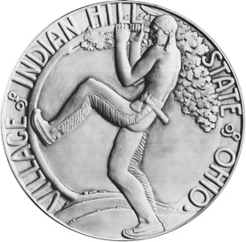

February 20, 2026

Dear Terrace Park Resident and Indian Hill Water Customer:

We wish to make you aware of a situation that has arisen within the Indian Hill water system.

Just like it has with Terrace Park, Indian Hill has supplied water to Madeira for multiple decades in a mutually beneficial arrangement. In October 2023, Madeira signed a 20-year extension to this agreement. Then, two years into this agreement, Madeira notified the Village that it wanted to terminate this agreement and contract with Greater Cincinnati Water Works (GCWW).

While the Village was willing to enter negotiations with Madeira about this decision, it is essential that the Village works to protect the integrity and safety of the water distribution system. Madeira’s plans, as defined by its agreement with GCWW, would cause significant disruption to the water distribution network by reducing water volume through sections of the Village’s service areas. This network would have to be modified to ensure appropriate fire flows continue as needed.

Even though Madeira’s notice about terminating the agreement constitutes a breach of contract, the Village was willing to negotiate. For more than a year, the Village has tried to negotiate, reaching out many times but receiving no response. Without notice, Madeira brought suit against the Village on February 6, 2026.

It is unfortunate that Madeira has chosen to file a lawsuit regarding an issue that could have been handled through negotiations between neighbors – neighbors who have had a mutually-beneficial arrangement for three quarters of a century.

Please know that this issue will not affect your water service in any manner. We simply wish to make you aware of the situation and provide transparency. We will continue to share information with you about this issue as conditions warrant.


Sincerely

Dina C. Minneci
City Manager

